IF THEN ELSE / CONTAINS / NOTIFICATION

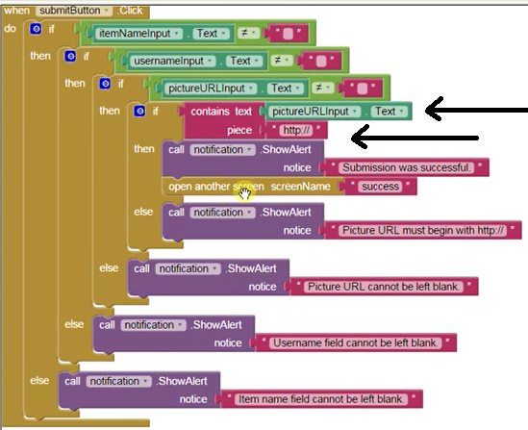

itemName: [itemName, pictureURL, username]

Storage / tinyDatabase rename as database

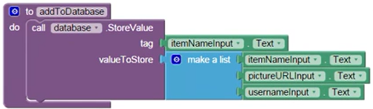

In App Inventor, the first item in a list is index 1

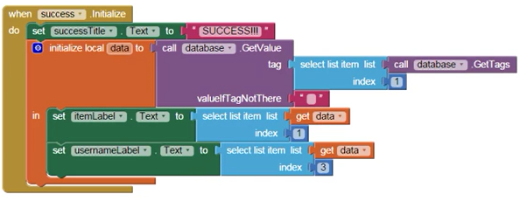

Cuando carga app

Ponga texto “Success”

Inicialize variable local “data”

Llame tinyDB database y traiga

Lista desde index 1

Asigne a itemLabel data[1]

Asigne a userNameLabel data[3]

<https://www.youtube.com/watch?v=NnCqYAlX76Y>